- \Operation\Strip transfer, unit C \Strip transfer, slide
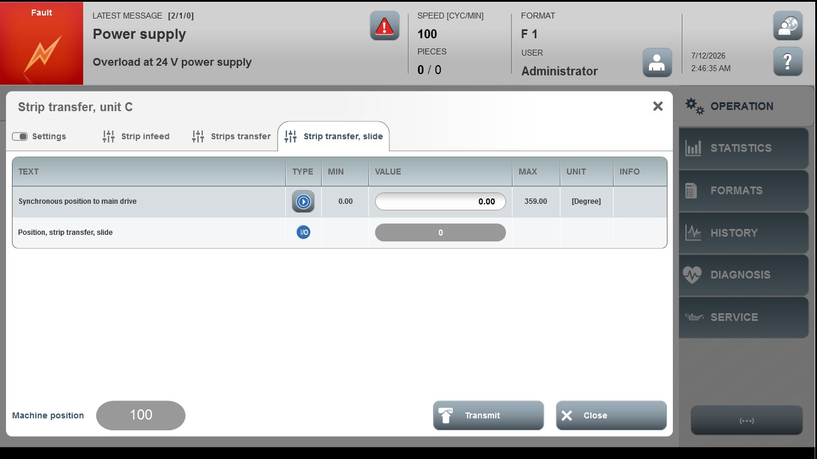

Acceptance criterion | Limits | Pass / Fail: Dev-No. | Date | Initials
Screen matches screenshot | N / A
Synchronous position to main drive | 0.00…359.00

